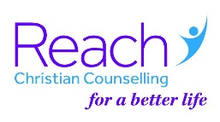
Gift Aid Form

Reach Merseyside
85a Allerton Road, Liverpool, L18 2DA

❑ I want Reach to treat as Gift Aid all donations made since 6th April 2001 and all future donations until I notify you otherwise. I have paid enough UK income or capital gains tax to cover all my charitable donations; other taxes such as Council Tax and VAT do not qualify. I will advise Reach of any change in my circumstances.
❑ I am not a UK taxpayer but I will notify Reach if my circumstances change.

Name: ...........................................................................................
Address: ...............................................................................
.......................................................................................................
.........................................................Post Code: ...........................

Signature: ................................................................ Date: ........................

Reach Merseyside is a Registered Charity No. 701330 Company limited by Guarantee No. 2235584

